Updated Aug 21 to incorprate the new Portal screens and processes
IMPORTANT READ THIS FIRST

- Your upload file must contain all of the columns shown on the template document even if they contain no data. The upload template will include a column for each possible data item so for a UDF, 12 fields can be added so there will be 12 columns in addition to the required fields.

- Once you have save your upload file as a .CSV, DO NOT SAVE again when exiting as the formatting you have just completed will change back to the defaults.

- Date format – Date formats are not always translated into the required format for the field they are being uploaded to. E.g in a UDF the Date From field will appear in the correct format DD-MMM-YYYY but any dates contained within the body of a UDF will not. You must therefore format these dates in the upload file first.

Preparing the data to upload

Navigate to : CorePortal > Administrator Dashboard > Data Migration

- In the Data Migration Templates Widget search for the relevant template.

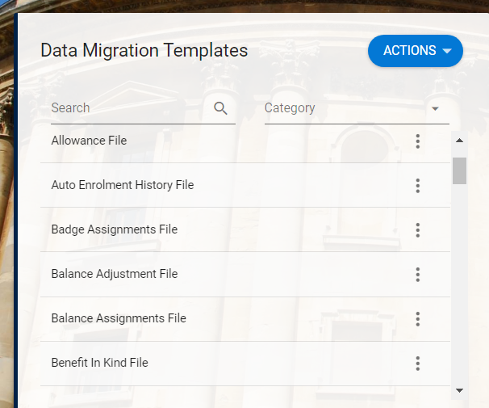

- Click on the Ellipses against the file you need. Download the Template AND the Helper.

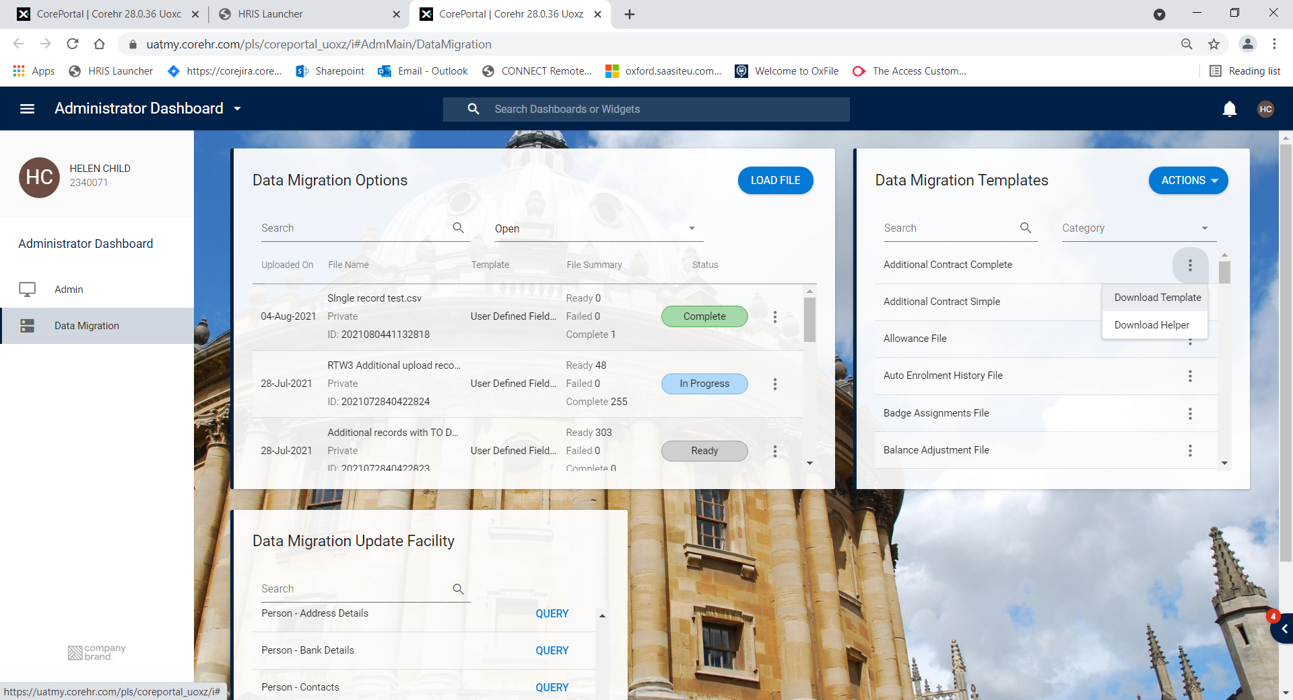

- The template shows the fields required, format and other related information.

The example below is from the template for a UDF:

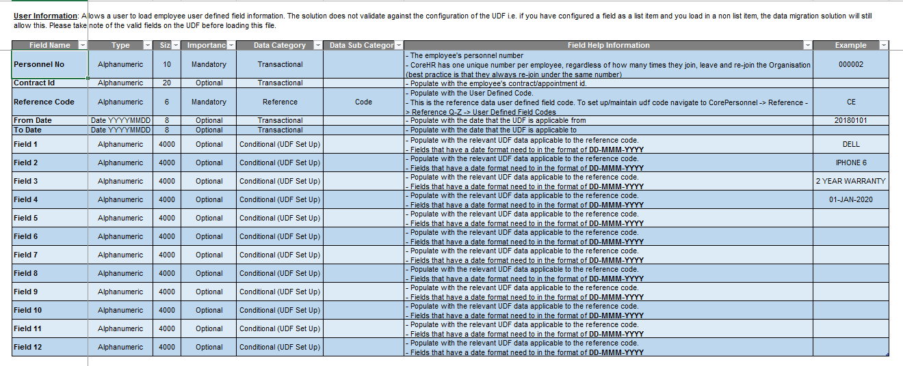

- Format your file so that the columns correspond to the template and all fields are formatted as text (ensuring dates include the 0 at the beginning e.g. 01 not 1).

- From within your upload file, open the template file. In step 1 of the import wizard, choose Delimited (default) and tick if your data has headers. Click NEXT.

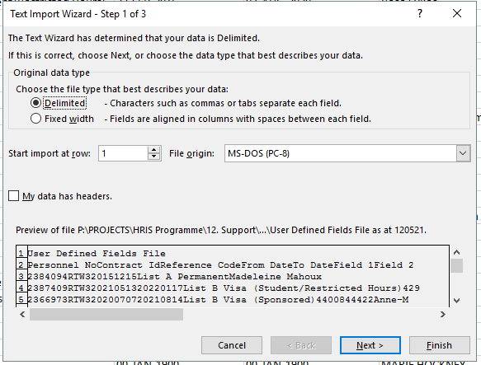

- In step 2 of the wizard leave Tab selected then select either Comma or Other – and enter a pipe (|) as applicable. Click NEXT.

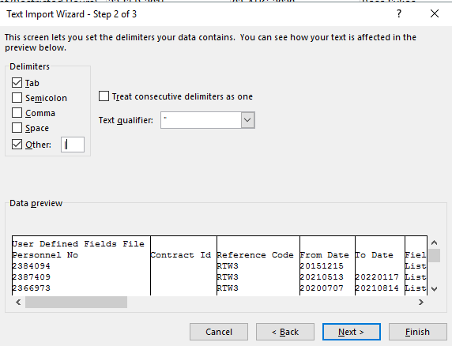

- In step 3 keep the default settings and click FINISH.
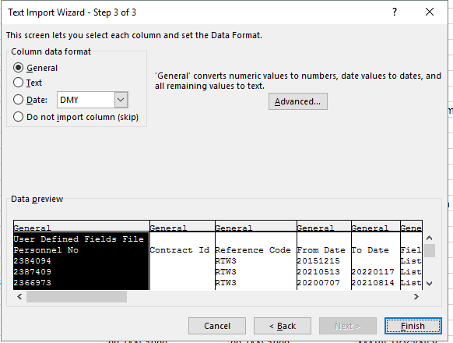

- A blank file will open (the example below is for uploading UDF data). Copy and paste your data into this file (with or without the header row as applicable).

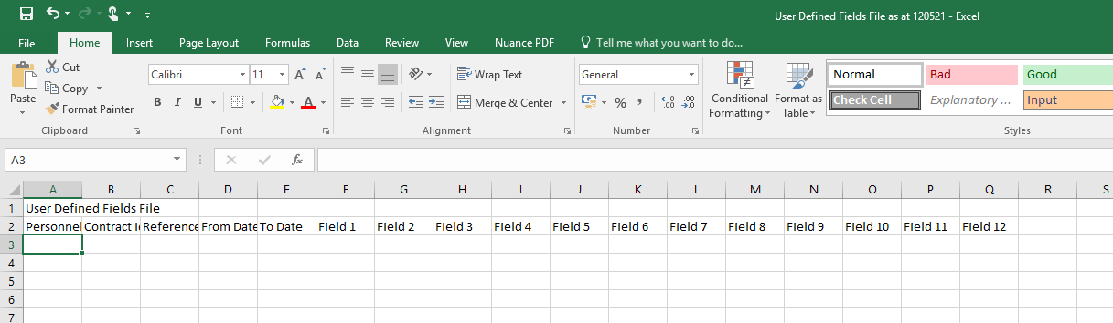

 | You may find it helpful to apply a colour to the columns that will be uploaded, especially if you have blanks columns at the end of your data that will be included in the upload.

- Save as a CSV (comma delimited) file.

 | Open your file in NOTEPAD++ to check that the formatting has been preserved and that there are no odd characters or errors before you attempt to upload it.

Uploading the data

Navigate to : CorePortal > Administrator Dashboard > Data Migration

- In the Data Migration Options widget click on LOAD FILE.

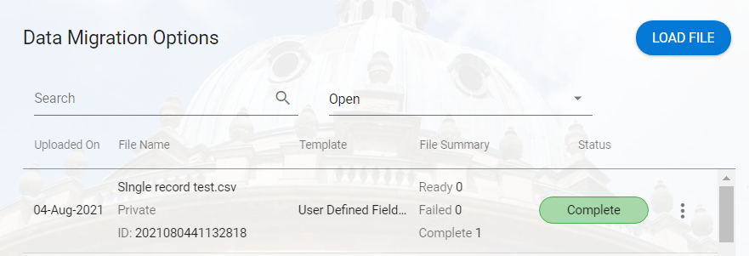

- Browse to find your file then click OK.

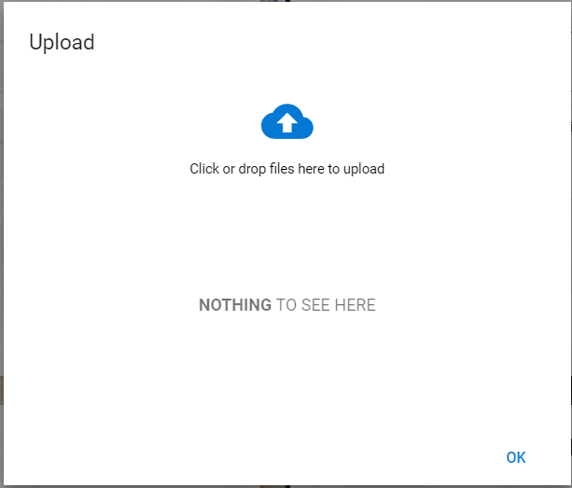

- Wait for the progress bar to stop and (Upload Complete) to appear. Click OK.

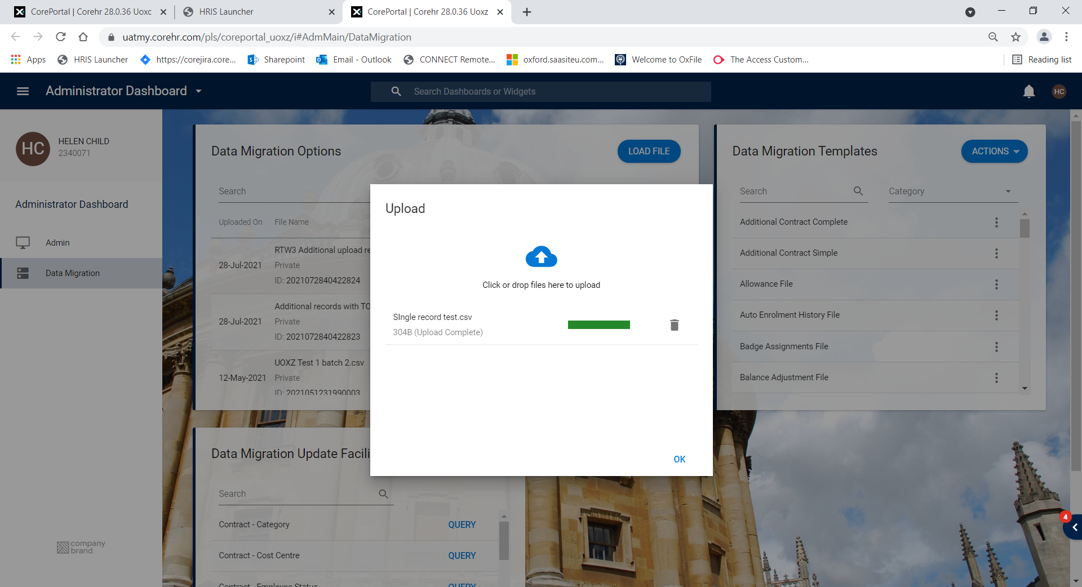
- Your file now appears in the list with the status READY

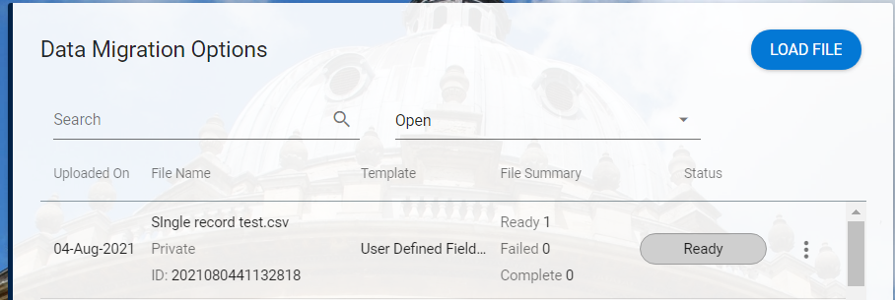

- Click on the ellipses and choose Edit to review the records.

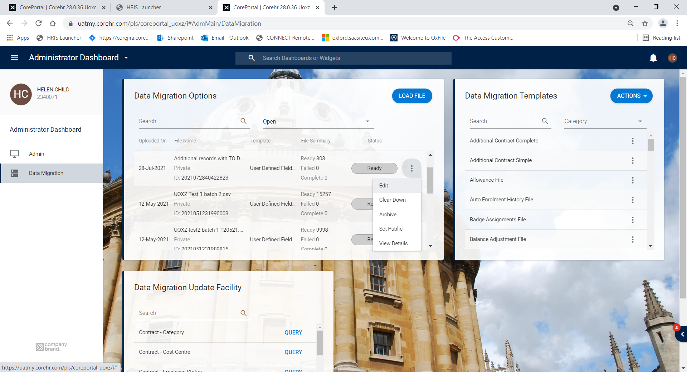

- Check that the data looks as expected.

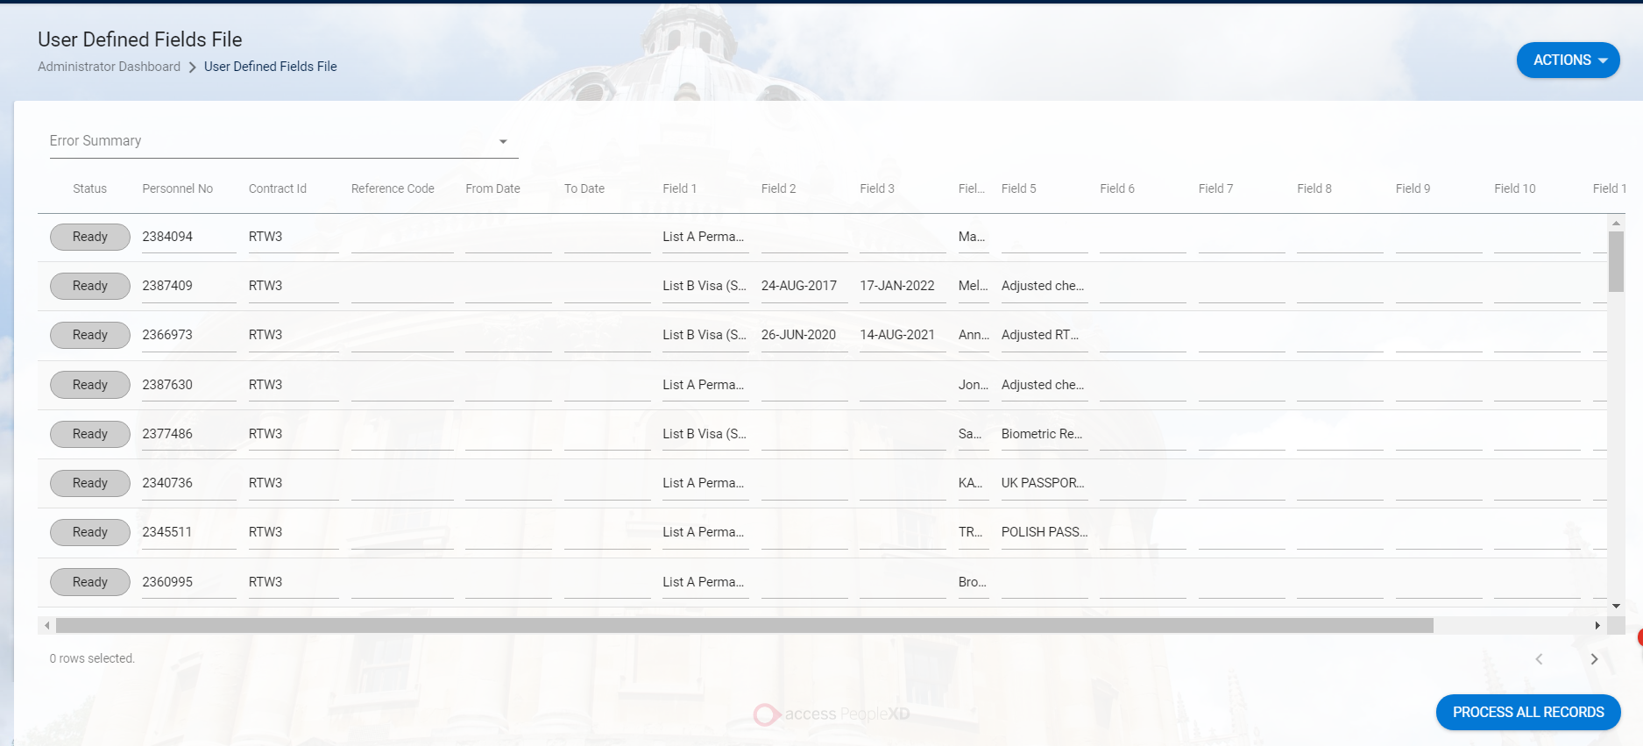

- If required you can process a single record to check the details:

  - Click on any row, the PROCESS RECORD button will appear. Click to process the chosen record.

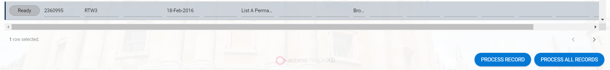

- To update all records click on PROCESS ALL RECORDS.

NB: The status will show as PROCESSING until all records have been updated.

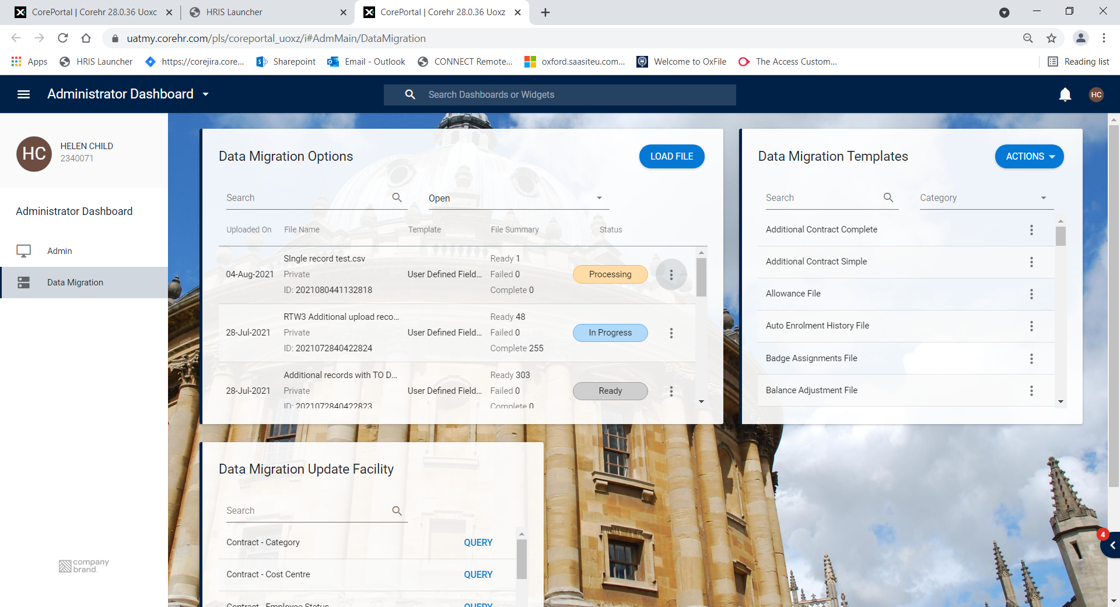

- When the file has been fully processed the status will show COMPLETE.



- If the file has failed validation the status will shows FAILED. The number of records failed will show in the File Summary column.

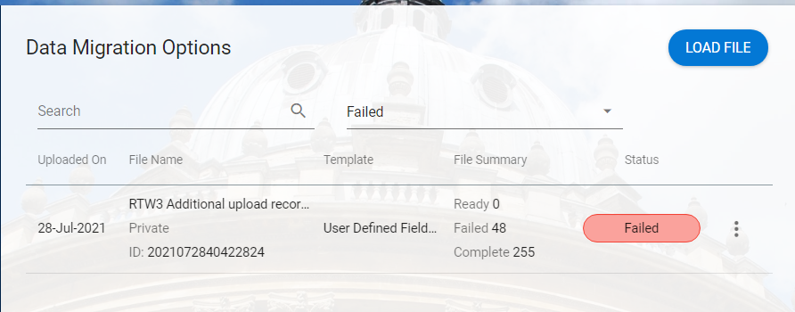

- Click on the ellipses and choose Edit to view the failed records.

- Correct your file as required and follow steps 1 to 8 again.

Quick steps for preparing and uploading a file

- Check that the data on the upload file matches the upload template
- From within the file to be uploaded, open the Core upload file
- Copy and paste the data into the new file
- Update any dates to the correct format. NB the TO/FROM date format in UDFs is not the same as other date fields.
- Save as a .csv file and Close without saving
- Open Notepad ++ and open the csv file you just saved.
- Check the formatting, spacing and date format.
- Remove special characters such as ; :
- Upload the .csv file in the Data Migration tool

